Dance Fusion 2023 Photography

Your Moment Photography, LLC Cell/*Text: 414-520-7657
Shannon Kendziora Email: shannonkendziora@gmail.com
1908 S 72nd Street Website: www.yourmomentphotography.com
West Allis, WI 53219
--------------------------------------------------------------------------------------------------------------------------------
Your Moment Photography, Milwaukee Wisconsin, will be the official photographer for Dance Fusion 2023.
There are two delivery options for your dance photo album(s):
- An online digital album – All edited photos are viewable, downloadable via my website
The 2023 pricing is: $125 for the first dance number. Then: $200 for 2 numbers, $275 for 3 numbers, & $350 for 4 numbers.

- If you would like a flash drive mailed to you in addition the digital album (+$15)
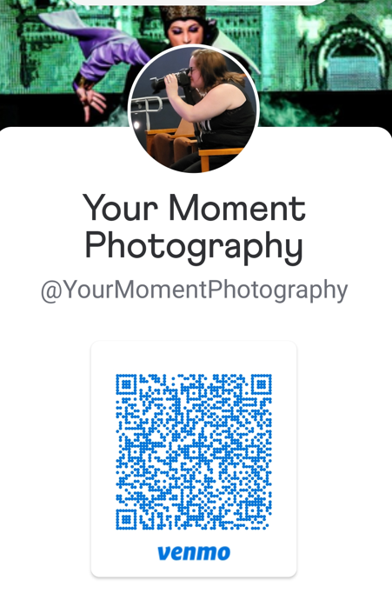
All photo files you receive are editable, sharable and can be printed locally! Payments can be made via cash, check, Square, or Venmo
*Checks should be made payable to: Shannon Kendziora.
Most dance numbers will receive 50-100 photos! Previous Dance showcase albums from last year and other Milwaukee Showcases are viewable via my website. To view examples of my photo work please visit: www.yourmomentphotography.com
NOTE: All dance numbers will be photographed, but only numbers that are ordered will be edited. If you forgot to turn in your from you can always mail it to me later later.
Your digital album and/or flash drive will be emailed/texted or mailed to you and will arrive between 4 to 6 weeks following the showcase. Or, once I have them all done.
Selecting a digital album allows for easy online access, sharing, and viewing and can photos can downloaded with relative ease as outlined below.
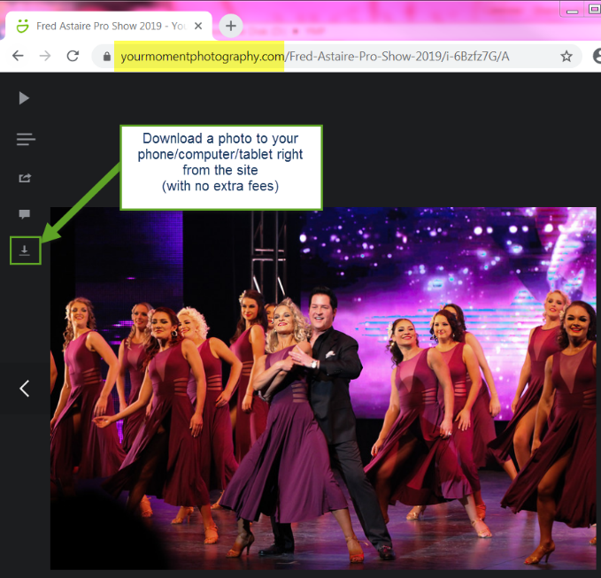
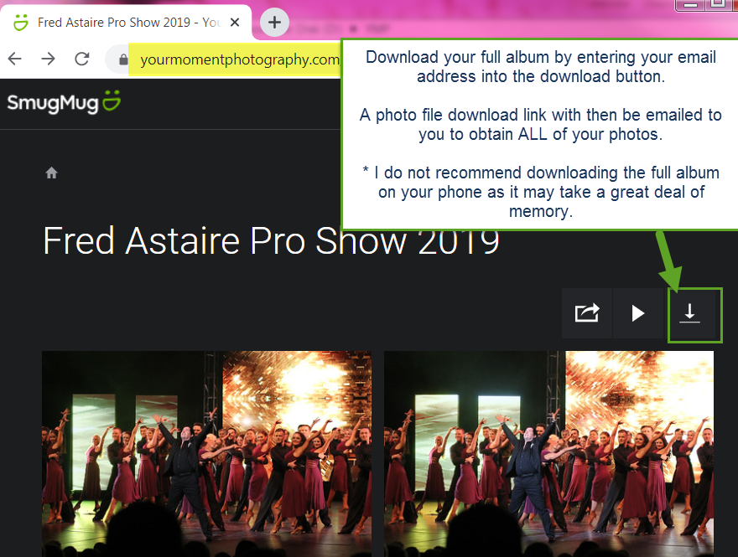

Dance Fusion 2023 Photography Order Form
Payment made via: Ck#_____/Cash/Venmo/Square
*Please make check payable to: Shannon Kendziora

Star Name(s): ____________________________________________________________________________
Address (I only need this if you are getting a flash drive mailed): ____________________________________________________________________________________________
____________________________________________________________________________________________
Email address(s): _____________________________________________________________________________
My studio is: ______________________________________________________________________________
*I would like a text message sent to me with my album link: Yes / No
Phone Number(s): _____________________________________________________________

Please circle the date(s) of your signature number(s)

Friday, April 21st Saturday, April 22nd

Please circle your photo album delivery preference:

- Digital Album/Download - edited photos will be viewable, shareable, & downloadable via my website/link I will email/text you.

1 number = $125 3 numbers = $275
2 numbers = $200 4 numbers = $350

- I would like a Flash Drive mailed to me, with my numbers, please add (+$15) order total

Dance name or # _________________________________________________________________________
Dance name or #__________________________________________________________________________
Dance name or #__________________________________________________________________________
Dance name or #__________________________________________________________________________
All photos will be reviewed/edited by Shannon and will include some black & white photos.
Your photo orders will arrive within 4 - 6 weeks following the event.
Digital albums will be added to my website as they are completed.
All dance numbers will be photographed but only numbers that are ordered will be edited.

