2026 CALENDAR
WEDNESDAY JANUARY 14: PRACTICE ROUNDS NIGHT
FRIDAY JANUARY 23: GATSBY PARTY
FRIDAY FEBRUARY 6: GUEST PARTY
THURSDAY FEBRUARY 19: PRACTICE ROUNDS NIGHT
FEBRUARY 25 - 27 FREDDIE AWARDS BALL REGIONALS NAPLES FLORIDA
FRIDAY MARCH 20: SAINT PATRICK'S PARTY
FRIDAY MARCH 27: STUDIO TEAM MATCH HEATS ONLY
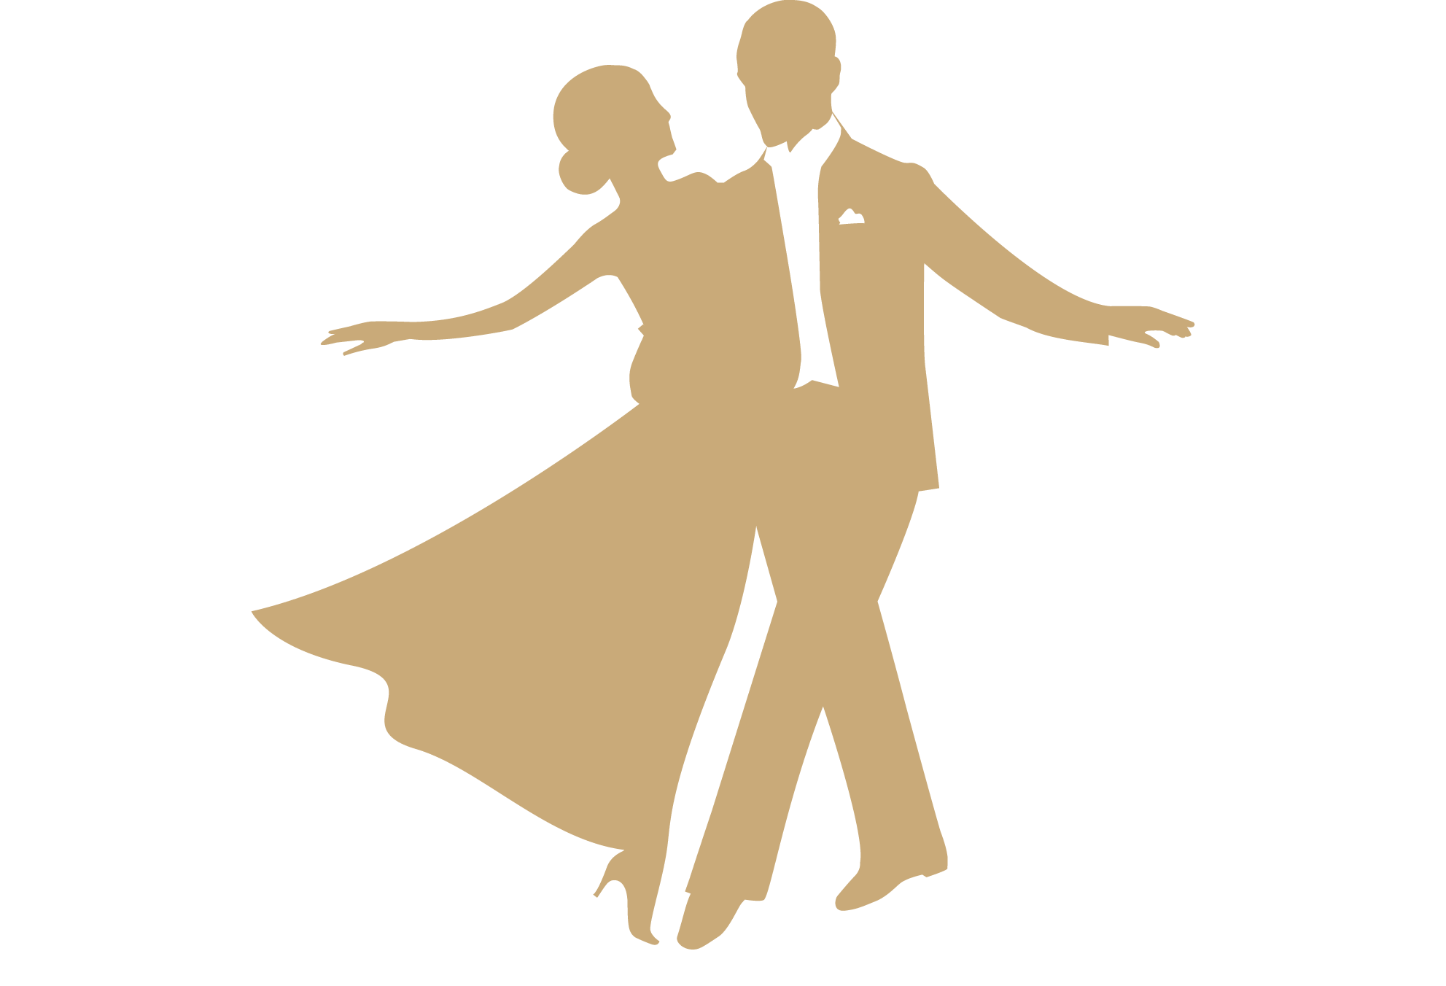
APRIL 7 -11: CCDC CROSS COUNTRY DANCE SPORT CHAMPIONSHIPS, NEW YORK
FRIDAY APRIL 24: GREATEST HITS STUDIO SHOWCASE (SOLOS ONLY)
WEDNESDAY MAY 6: PRACTICE ROUNDS NIGHT
MAY 20 - 23: CITY LIGHTS REGIONALS TURNBERRY AVENTURA
FRIDAY MAY 29: DISCO PARTY
THURSDAY JUNE 11: PRACTICE ROUNDS NIGHT
FRIDAY JUNE 26: JUNGLE PARTY
SATURDAY JULY 11: REGIONAL TEAM MATCH
FRIDAY JULY 24: LUAU PARTY
JULY 27 – 31: FAWC FRED ASTAIRE WORLD CHAMPIONSHIPS
WEDNESDAY AUGUST 5: PRACTICE ROUNDS NIGHT
AUGUST 19 TO 22 SUNDANCE CLASSIC MANALAPAN, FL
AUGUST 28 WHITE PARTY
THURSDAY SEPTEMBER 3: PRACTICE ROUNDS NIGHT
FRIDAY SEPTEMBER 18: FRED ASTAIRE “15” YEAR ANNIVERSARY PARTY
SATURDAY OCTOBER 3: REGIONAL CAMP - WEST PALM BEACH
FRIDAY OCTOBER 23: STUDIO TEAM MATCH
FRIDAY OCTOBER 30: HALLOWEEN PARTY
NOVEMBER 2-6: NDC FRED ASTAIRE NATIONAL CHAMPIONSHIPS ORLANDO
FRIDAY NOVEMBER 13: BROADWAY SHOWCASE
FRIDAY DECEMBER 4: HOLIDAY PARTY
DECEMBER 9 TO 12 HOLIDAY BALL INTERREGIONALS – MIAMI

PRACTICE ROUNDS NIGHT - STUDIO
WEDNESDAY JANUARY 14: PRACTICE ROUNDS NIGHT
THURSDAY FEBRUARY 19: PRACTICE ROUNDS NIGHT
FRIDAY APRIL 16: PRACTICE ROUNDS NIGHT
THURSDAY JUNE 11: PRACTICE ROUNDS NIGHT
WEDNESDAY AUGUST 5: PRACTICE ROUNDS NIGHT
THURSDAY SEPTEMBER 3: PRACTICE ROUNDS NIGHT

PARTIES – STUDIO
FRIDAY JANUARY 23: GATSBY PARTY
FRIDAY FEBRUARY 6: GUEST PARTY
FRIDAY MARCH 20: SAINT PATRICK'S PARTY
FRIDAY MAY 29: DISCO PARTY
FRIDAY JUNE 26: JUNGLE PARTY
FRIDAY JULY 24: LUAU PARTY
AUGUST 28 WHITE PARTY
FRIDAY SEPTEMBER 18: “15” YEAR ANNIVERSARY PARTY
FRIDAY OCTOBER 30: HALLOWEEN PARTY
FRIDAY DECEMBER 4: HOLIDAY PARTY
STUDIO OUTINGS – TBA

SHOWCASES AND TEAM MATCHES - STUDIO
FRIDAY MARCH 27: STUDIO TEAM MATCH HEATS ONLY
FRIDAY APRIL 24: GREATEST HITS STUDIO SHOWCASE (SOLOS ONLY)
FRIDAY OCTOBER 23: STUDIO TEAM MATCH
FRIDAY NOVEMBER 13: BROADWAY SHOWCASE

REGIONAL EVENTS
FEBRUARY 25 - 27 FREDDIE AWARDS BALL REGIONALS NAPLES FLORIDA
MAY 20 - 23: CITY LIGHTS REGIONALS TURNBERRY AVENTURA
SATURDAY JULY 11: REGIONAL TEAM MATCH
AUGUST 19 TO 22 SUNDANCE CLASSIC MANALAPAN, FL
SATURDAY OCTOBER 3: REGIONAL CAMP - WEST PALM BEACH
DECEMBER 9 TO 12 HOLIDAY BALL INTERREGIONALS – MIAMI

NATIONAL EVENTS
APRIL 7 -11: CCDC CROSS COUNTRY DANCE SPORT CHAMPIONSHIPS, NYC
JULY 27 – 31: FAWC FRED ASTAIRE WORLD CHAMPIONSHIPS
NOVEMBER 2-6: NDC FRED ASTAIRE NATIONAL CHAMPIONSHIPS ORLANDO
FOR ADDITIONAL INTERREGINALS, PLEASE VISIT FREDASTAIRE.COM

