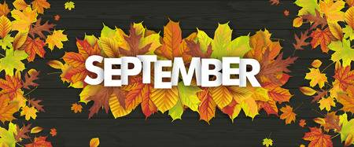 | 2019
Sunday | Monday | Tuesday | Wednesday | Thursday | Friday | Saturday
1 | 2 | 3 | 4 | 5 | 6 | 7
 | Labor Day  Studio Closed | Newcomer Ballroom  Dance Positions 7:00 | Strength and Yoga  UNITED STATES DANCE CHAMPIONSHIP COMPETITION  For Ballroom 7:00 | Ballroom Fitness  7:00 | Beg & Adv Cha Cha 7:00  Crazy Sock Party 7:45 | 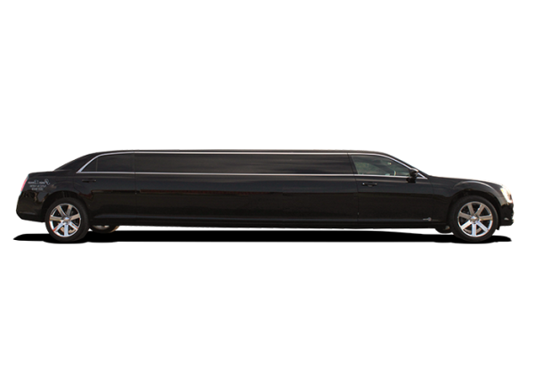  Night Out USDC!  Your text here  Your text here  Your text here  NIGHT OUT
8  Christina Penatello  Coach! | 9 | 10 | 11 | 12 | 13 | 14
 | Lindy Hop  6:15 | Newcomer Ballroom  Timing & Rhythm 7:00 | Strength and Yoga  For Ballroom 7:00 | Ballroom Fitness  7:00 | Beg & Adv Foxtrot  7:00  Old Hollywood Party 7:45 | La Blast
15 | 16 | 17 | 18 | 19 | 20 | 21
 | Lindy Hop  6:15 | Newcomer Ballroom  Dance Characteristics 7:00 | Strength and Yoga  For Ballroom 7:00 | Ballroom Fitness  7:00 | Hustle 7:00  Hippie Party 7:45
22 | 23 | 24 | 25 | 26 | 27 | 28
 | Lindy Hop  6:15 | Newcomer Ballroom Blending 7:00 | Strength and Yoga For Ballroom 7:00 | Ballroom Fitness  7:00 | Beg & Adv Rumba 7:00  Sept B-Day Party 7:45
29 | 30 |  |  | Dance Fantasy  Van Wezel Showcase  10/12/19
Lindy Hop
6:15
 |  | Your text here
September Birthdays!
Whitney Verdoni- 09/11 Barbara Lutz-09/13
Ivan/Sharon Gould-09/13 John Lewis- 09/21

